Lab #8 Protists and Fungi

Concepts of Biology: Manual of Laboratories and Review Activities
Second edition; Author: Christopher J. Harendza, Ph.D.; Department of Biology; Montgomery County Community College; Modified by Amy Vallette.

Part One – Observation and Identification of Protist (Phytoplankton)

Using a Dichotomous Key
A dichotomous key is a tool we often use in biology to help identify unknown organisms. “Dichotomous” means divided into two parts, hence the dichotomous keys always present two choices based on the key characteristics of the organism in each step. Keys are set up in a way that the user is presented with “either-or” choices that direct the user to the next pair of choices and so on until identification is made.
Directions: Use the following dichotomous key from Carolina Biological to identify the algae found in their Survey Mixture. These images are all organisms that we could have potentially seen in lab.
Dichotomous Key for Algae Identification-
1. Are the organisms unicellular (i.e. no colonies or filaments)? Proceed to # 2
1. Are the organisms colonial or filamentous? Proceed to # 3
2. Are the cells golden brown, longer than broad? When viewed from side, are the
tips blunt or square? When viewed from the top, do they have tapered ends? =Synedra (Diatom)
2. Are the cells bright green with a slight crescent shape?
Are there granular round vacuoles at the edge with a central clear area? = Closterium
3. Are the cells arranged in a filament (end to end)? Proceed to # 4
3. Are the cells arranged in clusters, aggregates, or spheres? Proceed to # 6
4. Do the cells have obvious chloroplasts and distinct internal structures?
Is the cell 3-4 times longer than broad? Are the cells bright green? Procced to # 5
4. Do the cells have no obvious chloroplasts and distinct internal structures?
Are the cells bluish green with a dense granular interior? Are the filaments
interrupted by large thick-walled structures (called heterocysts)? = Anabaena
5. Are the filaments narrow? Do the cells have a large clear area with the
chloroplasts concentrated toward the cell wall? = Ulothrix
5. Are the filaments wide with the chloroplasts occupying the entire cell? Are
there some large dark spheres (female structures) present in the filament? = Oedogonium
6. Is the colony small and composed of 3-24 cells? Is the colony one cell thick
and non-motile? Proceed to # 7
6. Is the colony large, round and hollow composed of 500 cells? Are there
“daughter colonies” within? Is it motile? =Volvox
7. Is the colony a flat plate of 6-24 polygonal cells that are somewhat circular? =Pediastrum
7. Is the colony composed of 4 spindle shaped cells connected side by side? Do
some of the cells have long spines? =Scenedesmus

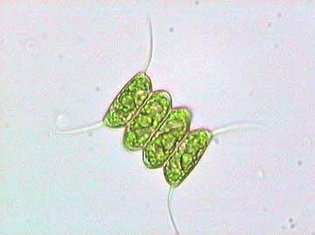
Image 1 (400x) Image 2 (400x) Image 3 (400x)
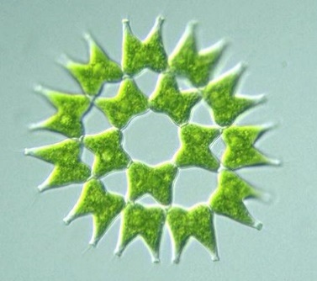
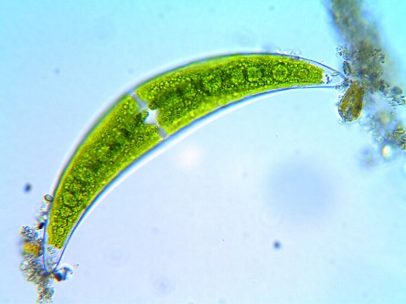
_______________________ ________Pediastrum__________ ______Scenedesmus_____

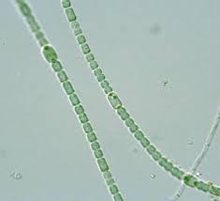
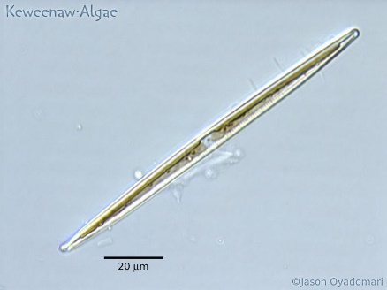
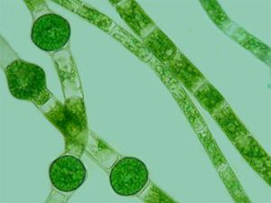
Image 4 (400x) Image 5 (400x) Image 6 (400x)

____Oedogonium__________ _Synedra_______________ _______Anabaena___________

Questions:
- Which of the above organism would be a member of the Domain Bacteria? Anabaena
- All the other organisms are members of which Domain? Fungi domain
What Kingdom are they members of? Kingdom- Eubacteria
- How are cyanobacteria different than green algae? How are they similar? Cyanobacteria and algae do possess various carbon transporters that are inorganic these transporters serve in increasing the CO₂ concentration that is at the site of Rubisco. CCMs on the other side presumably evolved due to the CO₂ enzyme of fixation which has the low catalytic rate. It also expresses the competitive oxygenase together with carboxylase kind of activities. The rates of the two activities depend on the O₂, CO₂ ration based on the active site of that enzyme.

- What is the role of green algae in an aquatic ecosystem?
Algae are the main source of energy and food to other organisms in the ecosystem. Being the primary producers, algae therefore forms the basic or the basis of the aquatic food chain.

- Suppose you were looking at two slides in lab; one was of cyanobacteria and one was green algae. If the label were missing, how could you distinguish between the two?
d. You could not distinguish between the two, as they are both members of the same kingdom.

Part Two: Observation of Protist (Zooplankton)
Directions: Do a search for a protist that is found in freshwater or salt water but one that is not algae. Look for an image that was taken from under a microscope at 400x. Draw it in below. List the site you found the image. Answer the following questions.
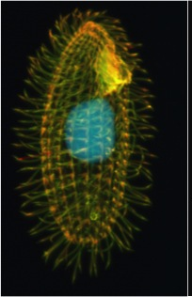
- What is the method of locomotion for the protist you found?
Cilia

- What makes this protist more animal like than plant like?
It is animal like since it uses cilia for locomotion from one point to another

Freshwater _ (400x)
Site used:

Part Three: Fungal Growth
If we had been in class, you would have been given a SAB petri plate. Like any culture dish, this contains a nutrient agar which allows microorganisms to grow. However, the SAB plate, unlike the plates used in Lab #7, contains a very high concentration of glucose that inhibits the growth of bacteria. After collecting a sample from around school (outside – dirt or leaves maybe; the sink; the bottom of your shoe, etc.,) and allowing it incubate, we would have grown a sample with little bacteria growth but a large amount of fungal growth.
Directions: Observe the following plate (which represents what we might have seen in lab)
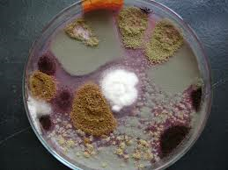
- Approximately how many different species of fungi are growing on the plate?
6 species of fungi

- Describe the appearance of the different fungi including color, texture, presence of spores, etc.

Hyphae it is along, branching filamentous structure kind of actinobacterium, oomycete and fungus. Hyphae are the basic main mode of a vegetative growth as they are collectively known mycelium.

Part Four: Microscopic Image of Fungi
Both of the following images were taken at 400x.
Directions: Label hyphae, the cell wall, fruiting bodies; and spores.
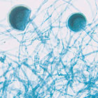
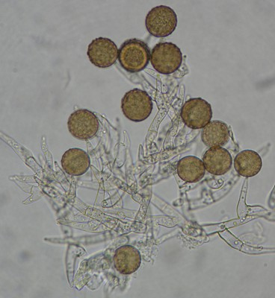

- What are hyphae?
C. threadlike filaments that make up fungal bodies

- What mode of nutrition do fungi exhibit? Explain how this is carried out specifically.

Fungi mainly get their nutrition by absorbing the organic compounds from the environment. They are heterotrophic; they depend on carbon which is obtained from other organism for their metabolism and nutrition. They also use variety of organic substrates mainly for growth.

- What is the role of the fruiting body and spores?
Their role is help in maintaining the number of tan cells despite the yellow variants.

- What would you say is the most significant beneficial role that fungi play in our ecosystem?
The most significant role of fungi that is beneficial to the ecosystem is that it the basic food and energy supply to every member of the ecosystem.

Part Five: Nature Walk
Directions: Take a short walk outside (or long walk!) and look for the following things. (If you cant please use clear pictures that you can find) Upload the pictures (insert them in this) and answer any questions.
- Look for green algae that often grows on sides of buildings. Take a picture of the algae and upload it here or email it.
What is true about the location where you find the algae? Why? (In other words, is it always growing on all sides of the building? If not, what is true about the side it is growing on?)

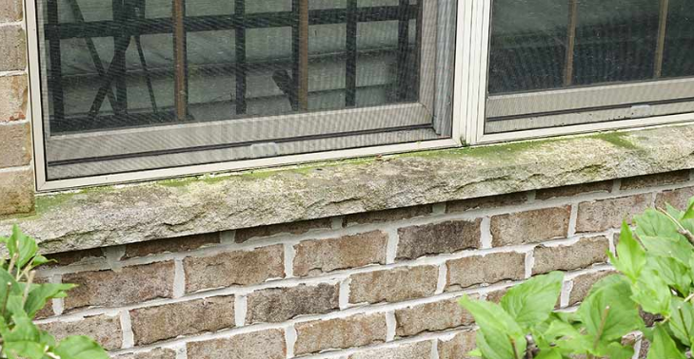
The truth about the position where it grows is that it is always wet. This is because at the building where I took the picture is where it rains but sunlight don’t reach there during the day thus making the place always wet as it makes it conducive for algae to grow.

- Look for a fungus– maybe on a rotting piece of wood, your produce drawer if you haven’t cleaned it out recently, or under leave debris outside. Maybe you even have purchased a fungus and it is in your home (think kitchen – Not a product of a fungus but the fungus itself). Take a picture of what you find and upload it here or email it.
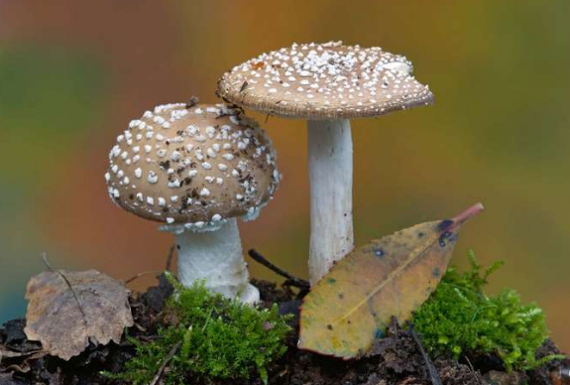

- Find lichen growing. Lichen is usually found on the trunks of trees, on rocks including tombstones and similar structures, on park benches, fence posts; etc. Take a picture of what you find and upload it here or email it.

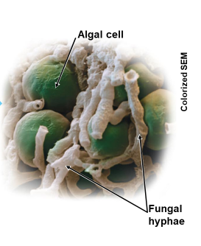
Lichen is composed of two different organisms living in a symbiotic, mutualistic relationship (see diagram). What are the two organisms?

Fungus and alga

Describe the role that each of these organisms has in the lichen body.

The fungi do absorb water together with mineral salts as it transfers them to the algae. Then the algae will prepare food with those mineral salts and water with the help of chlorophyll. The manufactured or prepared food is later shared with the fungi which is heterotrophic.

Why are lichens considered important to an ecosystem?
During the succession in the primary on the barren areas that are rocky, it is noted that lichens are the first to inhabit the area thus refereed t us as the pioneer species. They also secret certain acid that is organic which has the significance in dissolving the rocks as it then initiates the process of soil formation. The significance of this is that higher plants for example mosses become able to hold on the loose soil which is formed by this process. Therefore lichens do an important role in establishment of different biotic communities as they also help in biological succession.

